Note: given the fact that you’re ‘obliged’ to answer the weekly questions, try to profit the most from the task:
- Start by reading the lecture notes (twice).
- Looking at them as little as possible, answer the questions.

The answers of the questions of week 8 should be handed to me one week after lecture 16. They should be manuscript (not typewritten) and preferably based on schemes (as I do in the whiteboard). Keep a copy for yourself.

Please write WEEK 8 in bold at the beginning of your answers

Week 8

L15: Minsky

L17: Minsky’s explanation of economic booms and recessions.

Basic notions

1.What are the sources of companies’ funding?

2. Which are the two regular obligations imposed by debt?

3. What’s the difference between cash-flows and profits?

4. What’s the difference between the return on assets (ROA) and the return on equity (ROE)?

5. Suppose the interest rate is 10%.
a) If a business has financed 99% of the purchase of its capital with debt, under which circumstances will its cash-flows be insufficient cover its interest payments?
b) If a business has financed only 1% of the purchase of its capital with debt, under which circumstances will its cash-flows be insufficient cover its interest payments?
c) In which of the two cases will the business be able to borrow to undertake new investments? Explain.

6. The higher is a company’s debt relative to its assets, the higher is the probability that its interest payments will exceed its production cash-flows. Why?

7. Suppose that the rate of return on assets exceeds the interest rate by 5 percentage points.
a) By how much will profits increase if a company raises a loan of 100 euros to invest in new assets? Explain.
b) The value of the company’s equity is 100 euros. By how much will its profit rate increase? Explain.

8. “Changes in AD over the cycle are associated with roughly proportional changes in firms’ revenues.” Do you agree? Explain.

9. “Changes in AD over the cycle are associated with roughly proportional changes in firms’ profits.” Do you agree? Explain.

Figure 1:
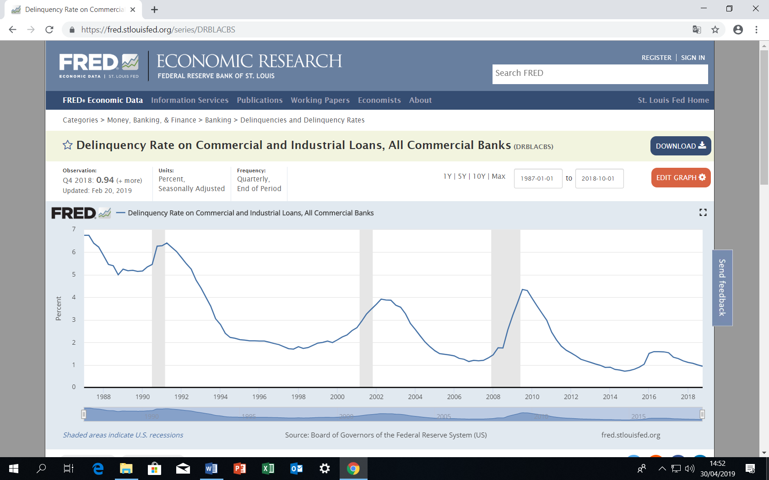
Figure 2:
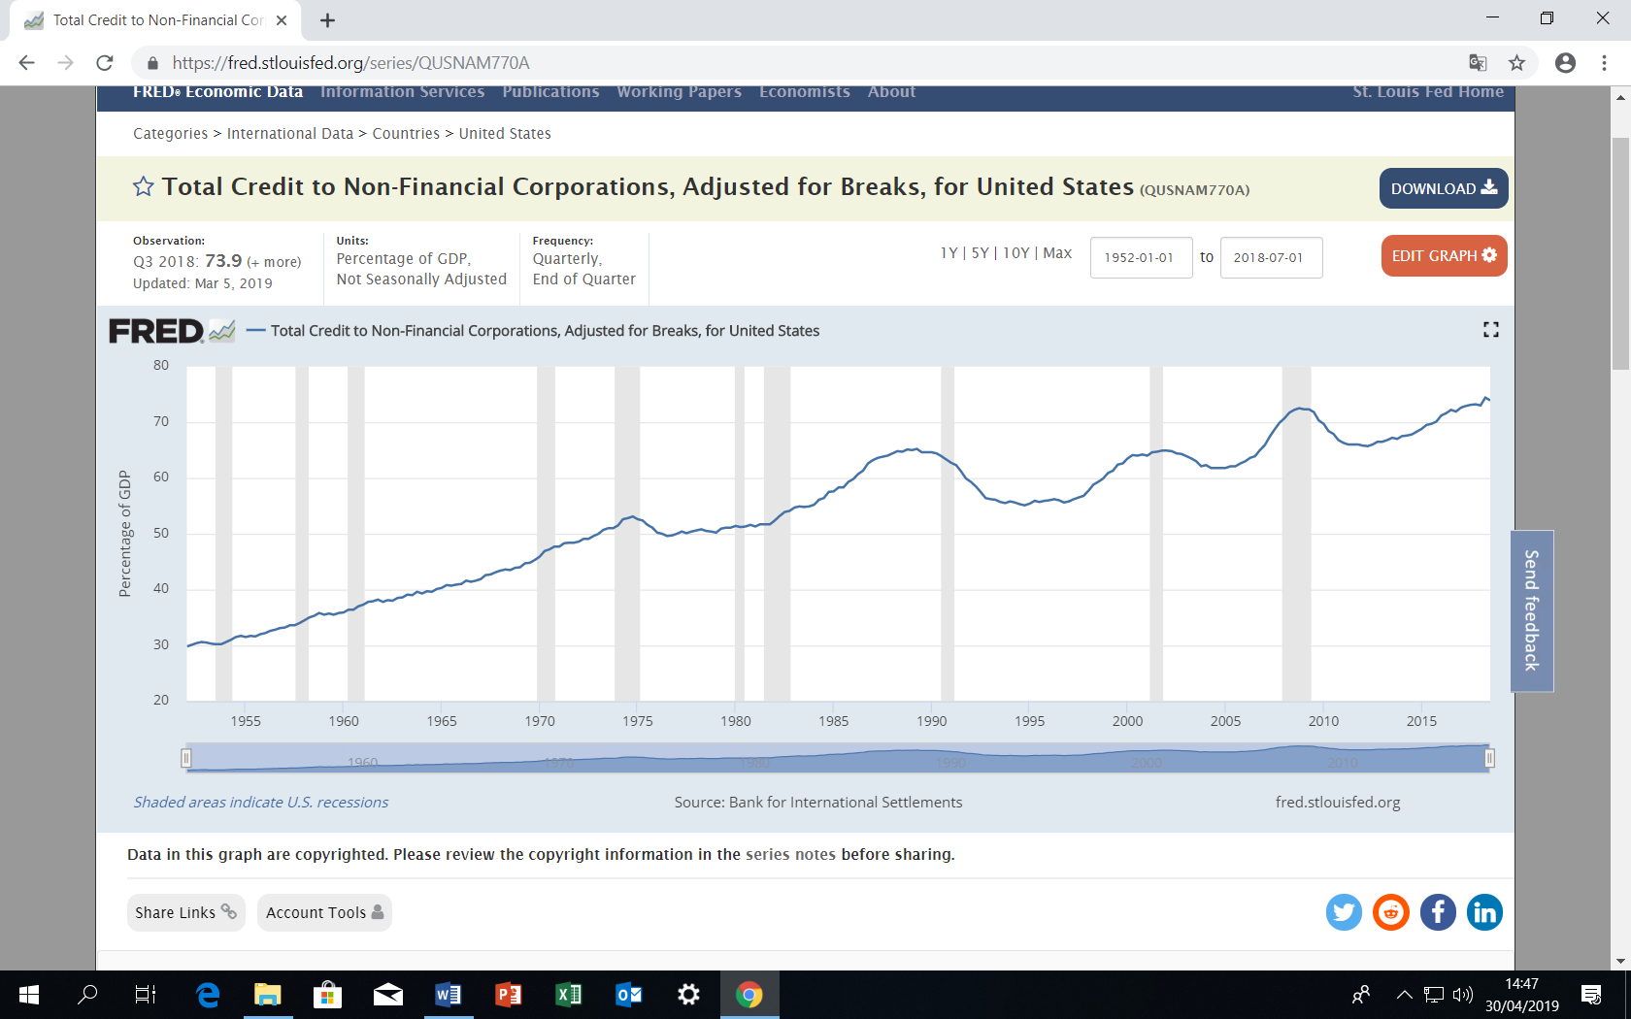

How contractions lead to depressions

10 a). Why do businesses’ debt-to-assets (proxied by debt-to-GDP in figure 2) ratios fall during one or two years after an economic contraction?
b) What are the macroeconomic implications of that fact? Explain.

Explanation of the start of expansions and of their self-sustained nature

11. a) Why are businesses’ debt commitments easily met at the beginning of expansions?
b) What’s the effect of that fact on investment? Explain.
12. When ROA exceeds the interest rate on credit, what tends to happen with investment financed with debt? Explain.

13. What does start the rise in output at the beginning of an expansion?

14. How can that first rise in output lead to a new rise in output in the next quarter, and so on? Key question.

Explanation of the upper-turning point and of the self-sustained recession

15. a) According to Minsky, what does trigger an increase in business defaults after a long period of expansion?
b) Do this graph (depicting the Fed’s interest rate) coupled with figures 1 and 2 support or contradict Minsky’s claim?
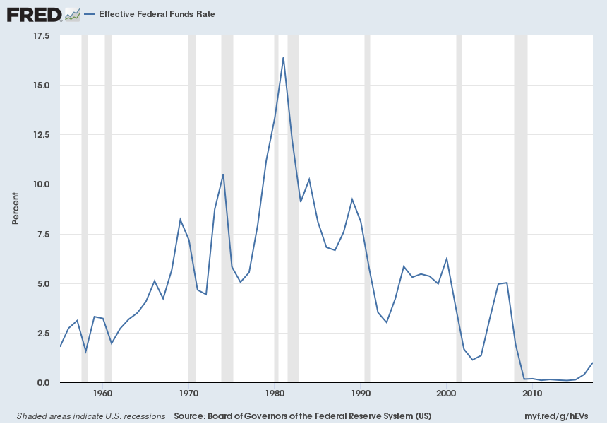

16. How can the rise in defaults cause a decline in output?

17. Why can a decline in output in one quarter lead to a new decline in output in the next quarter, and so on? Key question.

18. a) Characterize the credit to buy houses in the US in 2002-6.
b) Why did the Fed raise interest rates after Jan 2005?

19. What was the consequence of the Fed’s rate rises?

20. When banks start:
a) Fearing a decline in GDP, they may trigger a decline in GDP that would otherwise might not occur. Why?
b) Believing in strong GDP growth, they reinforce the probability of that happening. Why?

21. What led to to the Eurozone debt crisis?
Keynesian consumption:

22. Under which world would people borrow to finance consumption of low-income periods do as to make it equal to consumption of high-income periods? Explain.

23. Why should do people borrow very little to finance consumption of low-income periods?

24. What are the two reasons why people tend not to use past savings to limit the decline in consumption during recessions?

25. a) Is the marginal propensity to consume higher under the Keynesian or Friedman’s consumption functions?
b) Which consumption function generates a more unstable economy? Explain.

